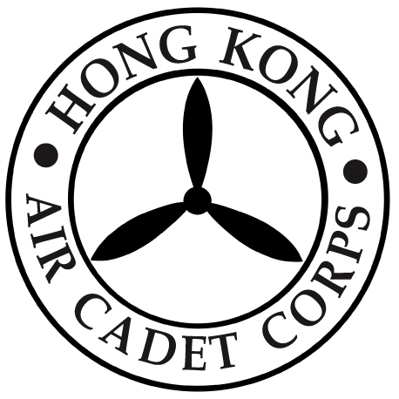

HONG KONG AIR CADET CORPS

From : Commanding Officer  Ref : Face Masks | To : All Members  Cc :
Tel : 2712 8900  Fax : 2715 6944 | Date: 26 June 2020

Distribution of Face Masks

With the wide spread of the novel coronavirus epidemic, the Corps was very fortunate and has received 9,100 (182 boxes) face masks and 100 sanitizing packs (5 face masks & 1 hand sanitizer) donation to our Corps members. Distribution arrangements as follows:-

- Cadet / University Squadron and Flight
100 (2 boxes) face masks will be distributed to each squadron and flight. Would all OC Sqn and OC Flt please make appointment with HQ colleagues to collect the item.

- Cadet and Officer Trainee
2,500 (50 boxes) face masks and 70 sanitizing packs will be given out to Cadets and Officer Trainees on a first come, first served basis. Interested members may fill out the form at the link below. Successful applicants will receive a notice of collection.
https://docs.google.com/forms/d/e/1FAIpQLScrUbYMdxatZvOO41YO4AC2QLoI7RO0LgsSXLYAK62CzVWzOA/viewform

- Other Major Unit
The unallocated supplies will be given out to other major units for upcoming Corps level activities. Interested unit heads may contact HQ colleagues for collection. All items are available on a first come, first served basis while stock lasts.

Wishing everyone good health and staying safe.

ML CHAN
Group Captain
Commanding Officer

